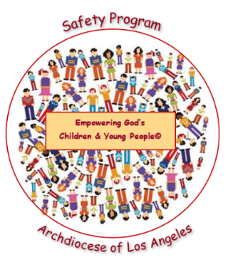
Empowering God’s Children and Young People© Safety Program
Year 1: Safe and Unsafe Safety Rules
Grades: Kindergarten – 8th
2026 – 2027 Permission Slip

To: [Parent or Guardian]
From: [Elementary School, RE (K-8)]
Subject: Empowering God’s Children and Young People© Safety Program
Date: [Date]
The staff of [Name of School or RE, Confirmation or Youth Program] and the Archdiocese of Los Angeles are committed to your child’s safety and well-being. We present the Empowering God’s Children and Young People© Safety Program to our students each year. Child sexual abuse continues to afflict our society. There is an ongoing need for children and young people to be empowered with the knowledge and tools to keep themselves and others safe from harm. This Archdiocesan Program includes a catechetical connection that highlights God’s love and desire for the health and safety of all children and young people.

We will be presenting “Year 1, Safe and Unsafe Touching Rules.” This lesson teaches the “Five Body Safety Rules and how to identify “Safe Adults and Unsafe Adults.” This program has proved invaluable in empowering our children and young people to know they have a voice and the power to keep themselves safe!

The program will be presented to our students during [Month]. Parents or guardians must give permission for their child(ren) to participate in this Safety Program by returning the completed permission slip below. If you would like additional information regarding the Safety Program or to review the materials [Name, contact information].
[Name of School or RE, Confirmation or Youth Program]

Empowering God Children and Young People© Safety Program
Year 1: Safe and Unsafe Safety Rules
Parent/Guardian Permission Slip
Grades: Kindergarten – 8th
2026– 2027

My signature below confirms that my child,________________________________ has my permission to participate in the Empowering God’s Children and Young People© Safety Program “Year 1: “Safe and Unsafe Touching Rules.” I understand I must complete and return this Parent/Guardian Permission Form for each child participating by [Date].
Child’s Name (printed): _______________________________________________________________
Parent/Guardian Name (printed): ________________________________________________________
Parent/Guardian Signature: ___________________________________________________________
Date: _______________________________

