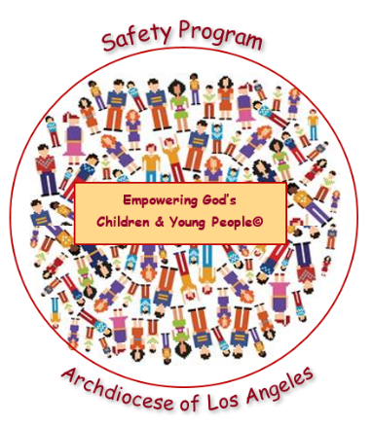
Empowering God’s Children and Young People© Safety Program
Year 2: Boundaries and Bullying
2024 – 2025 Permission Slip
Kindergarten – 8th

To: [Parent or Guardian]
From: [School or Religious Education]
Subject: Empowering God’s Children and Young People© Safety Program
Date: [Date]
The staff of [Name of School or RE Program] and the Archdioceses of Los Angeles are committed to your child’s safety and well-being. We present the Empowering God’s Children and Young People© Safety Program to our students each year. Child sexual abuse continues to afflict our society. There is an ongoing need for children and young people to be empowered with the knowledge and tools to keep themselves and others safe from harm. This Archdiocesan Program includes a catechetical connection that highlights God’s love and desire for the health and safety of all children and young people.

We will be presenting “Year 2: Boundaries and Bullying.” The goal of this lesson is to help children identify and establish personal boundaries and recognize the signs and dangers of bullying. All children must be taught the importance of protecting their boundaries to keep themselves and their peers safe from abuse. This lesson also identifies warning signs of online boundary and bullying violations. The program has proven to be invaluable in empowering all children to be vigilant in all their relationships.
The program will be presented to our students during [Month]. Parents or guardians must give permission for their child(ren) to participate in this Safety Program by returning the completed permission slip below. If you would like additional information regarding the Safety Program or to review the materials [Name, contact information].

[Name of School or RE Program]
Empowering God Children and Young People© Safety Program
Year 2: Boundaries and Bullying
2024 – 2025 Permission Slip
Kindergarten – 8th

My signature below confirms that my child, ________________________________, has my permission to participate in the Empowering God’s Children and Young People© Safety Program “Year 2: Boundaries and Bullying. I understand I must complete and return this Parent/Guardian Permission Form for each child participating by [Date].
Child’s Name (printed): _______________________________________________________________
Parent/Guardian Name (printed): ________________________________________________________
Parent/Guardian Signature: ___________________________________________________________
Date: _______________________________

