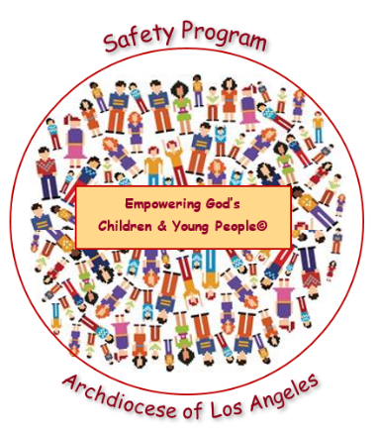
Empowering God’s Children and Young People© Safety Program
Year 1: Healthy and Unhealthy Relationships
2023 – 2024 Permission Slip
To: [Parent or Guardian]
From: [High School, RE (9-12), Confirmation, and Youth Program]
Subject: Empowering God’s Children and Young People© Safety Program
Date: [Date]
The staff of [Name of High School or RE, Confirmation or Youth Program] and the Archdioceses of Los Angeles are committed to your child’s safety and well-being. We present the Empowering God’s Children and Young People© Safety Program to our students each year. Child sexual abuse continues to afflict our society. There is an ongoing need for children and young people to be empowered with the knowledge and tools to keep themselves and others safe from harm. This Archdiocesan Program includes a catechetical connection that highlights God’s love and desire for the health and safety of all children and young people.

We will be presenting “Year 1, Healthy and Unhealthy Relationships.” The goal of this lesson is to help teens in High school be aware of the importance of healthy relations with peers, adults, and online. Participating in this Program will help teens recognize healthy relationships and avoid unhealthy relationships. The program has proved invaluable in empowering our teens to be vigilant in all their relationships in order to keep themselves safe.

The program will be presented to our students during [Month]. Parents or guardians must give permission for their child(ren) to participate in this Safety Program by returning the completed permission slip below. If you would like additional information regarding the Safety Program or to review the materials [Name, contact information].
[Name of School or RE, Confirmation or Youth Program]

Empowering God Children and Young People© Safety Program
Year 1: Healthy and Unhealthy Relationships
Parent/Guardian Permission Slip
2023– 2024

My signature below confirms that my child,________________________________ has my permission to participate in the Empowering God’s Children and Young People© Safety Program “Year 1: “Healthy and Unhealthy Relationships.” I understand I must complete and return this Parent/Guardian Permission Form for each child participating by [Date].
Child’s Name (printed): _______________________________________________________________
Parent/Guardian Name (printed): ________________________________________________________
Parent/Guardian Signature: ___________________________________________________________
Date: _______________________________

