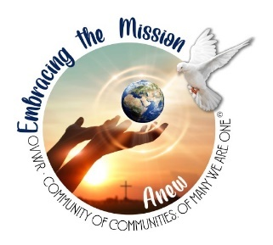
Major and Local Superiors Fall Meeting
with Archbishop Jose Gomez
Wednesday, September 21, 2022
9:30am – 1:00pm including lunch
Our Lady of the Bright Mount Parish Hall

Registration and Hospitality
Opening & Welcome – Sr. Elizabeth O’Donnell, OP, Sr. Maria Carlos, EIN
Morning Prayer – Sr. Marita Olanga, FDZ
Archbishop Jose Gomez
Stand-up break

Sr. Judy Dieterle, SSL (LASAW)
- Sr. Judy will give an introductory presentation to LASAW (who & what they are; what are their goals)
- Introduce Assessment Tool from S. M. Peter and AIG
- Call for volunteer communities to participate in pilot study with Tool

Inter-Congregational Vocation Promotion - Sr. Marita
Invitation to Study cohorts – S. Elizabeth
Inter-Congregational Contemplative Dialogue, Breakout groups –
Sr. Jeanette Kong, VDMF

Evaluation - Sr. Elizabeth

Lunch
With much gratitude to:
Sr. Maria Elena Gutierrez, OP for providing Simultaneous Translation
Vision of Hope, Dominican Sisters of Mission San Jose for providing
Translation Equipment

Thank you for coming!

