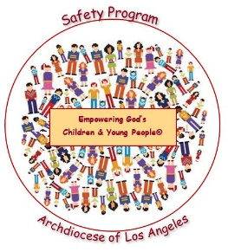***Empowering God’s Children and Young People©***

**Safety Program / Year 3: Internet Safety**

**“Teen Permission Slip”**

***TO: [Parent or Guardian]***

***FROM: [Person representing High School, Confirmation, Youth Ministry]***

***SUBJECT: “Empowering God’s Children and Young People©” Safety Program***

***DATE: [Date]***

We at **[Name of High School, Confirmation or Youth Ministry]** are committed to the safety and well-being of your children and in helping to empower them to protect themselves from child sexual abuse.

For this, the Archdiocese of Los Angeles has created “Empowering God’s Children and Young People©” Safety Program. For the 2019 – 2020 school year, we will be presenting **Year Three: Internet Safety** to all students in the month of ______________.Through these age-appropriate lessons, students will learn the advantages and possible dangers of using the internet and how to be safe and responsible when online. These lessons are based on the Nationally sponsored NSTeens© and SafeKids© Programs and will focus on some of the following basic Internet Safety Rules:

* Keep all post safe and positive and always consider “Who will see this?” and “What will they think?”
* Never post inappropriate images of myself or others.
* Keep personal information private.
* Always ask a safe adult when a post or pop-up makes me feel uncomfortable, scared or confused.
* Be supportive and respectful of others who might need my help with dangerous online activity.
* Never meet anyone face to face that I have only communicated with online.

The lesson has a “Parent/Guardian Take Home Activity” to help you discuss this important topic with your teen(s).

Included with this letter and permission slip is the “Citing and Resources” tool, which gives helpful websites that will provide valuable information on how to communicate with your teen(s) about online safety.

**If you have questions, need any additional information about the program or would like to review any of the materials, please feel free to contact [Contact Name] at [Contact Number/Email]**.



**“Empowering God’s Children and Young People©” Safety Program**

**Year 3: Internet Safety Permission Slip**

***(Please sign one form per child)***



I give my consent for my child to participate in the Archdiocese of Los Angeles “Empowering God’s Children and Young People©” Safety Program. I understand that I need to complete and return this Permission Slip to **[Name of High School, Confirmation or Youth Ministry]** by **[Date]**:

Child’s Name: Grade: ___________

Parent/Guardian’s Name (Printed):

Parent/Guardian’s Signature: Date:**