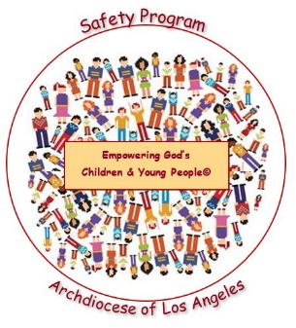

***Empowering God’s Children and Young People©***

**Safety Program / Year 3: Internet Safety**

**“Children’s Permission Slip”**

***TO: [Parent or Guardian]***

***FROM: [Person representing School or Religious Education Program]***

***SUBJECT: “Empowering God’s Children and Young People©” Safety Program***

***DATE: [Date]***

We at **[Name of School or Religious Education Program]** are committed to the safety and well-being of your children and in helping to empower them to protect themselves from child sexual abuse.

For this purpose, the Archdiocese of Los Angeles has created “Empowering God’s Children and Young People”© Safety Program. For the 2019 – 2020 school year, we will be presenting **Year Three: Internet Safety.** Through these age-appropriate lessons, students will learn the advantages and possible dangers of using the internet and how to be safe and responsible when online. The foundation of these lessons are NetSmartz© and the Four Internet Safety Rules:

* I will tell a trusted adult if anything online makes me feel sad, scared or confused.
* I will ask my parent/guardian before sharing personal information online.
* I won’t meet face-to-face with anyone from the internet.
* I will always use good “netiquette” (manners) and not be rude or mean to anyone online.

Each lesson has a “Parent/Guardian Take Home Activity” to help you discuss this important topic with your child.

Also included is a parent/guardian internet safety article that will provide valuable information on ways you can help protect your child online.

**If you have questions, need any additional information about the program or would like to review any of the materials, please feel free to contact [Contact Name] at [Contact Number/email]**.

**Year 3: Internet Safety Permission Slip**

**“Empowering God’s Children and Young People” © Safety Program  
*(Please sign one form per child)***

I give my consent for my child to participate in the Archdiocese of Los Angeles “Empowering God’s Children and Young People” © Safety Program. I understand that I need to complete and return this Permission Slip to **[Name Person from School or Religious Education Program]** by **[DATE]**:

Child’s Name: Grade:

Parent or Guardian’s Name (Printed):

Parent or Guardian’s Signature: Date: